AASTMT Leather Technology Center Services
Training and Testing

Dr. Ahmed Shoair
Dr. Ahmed Abd El Kader
Eng. Yassin Shaalan
Mr. Tarek Madkour

6 Sept. 2020

Revision History
Version | Date | Author | Description | Action | Pages
1.0 | 15/02/2020 |  | Creation of the document | C | 30

(*) Action: C = Creation, I = Insert, U = Update, R = Replace, D = Delete

Disclaimer

This project has been funded by the Erasmus+ Programme of the European Union.
The information and views set out in this publication are those of the author(s) and do not necessarily reflect the official opinion of the European Union. Neither the European Union institutions and bodies nor any person acting on their behalf may be held responsible for the use which may be made of the information contained therein.
Reproduction is authorised provided the source is acknowledged.
All rights reserved
Copyright ©INNOLEA Consortium, 2017-2020

Table of Contents
1 Training Courses: 4
1.1 Introduction to leather Processing 4
1.2 Chemical test methods for leather 4
1.3 Physical – Mechanical test methods for leather 5
1.4 Research and Development in Leather Industry 5
1.5 Environmental management in the leather industry 6
1.6 Managerial training: 6
2 Tests that can be performed: 9
2.1 Determination of Thickness 9
2.2 Determination of Apparent density and mass per unit area 9
2.3 Determination of tensile strength and percentage extension 9
2.4 Determination of tear load-single edge tear 9
2.5 Determination of tear load- Double edge tear 9
2.6 Measurements of stitch tear resistance 9
2.7 Test for adhesion of finish 9
2.8 Determination of flex resistance- Flex meter method 9
2.9 Test Methods for upper and lining- Flex resistance 9
2.10 Footwear- Test methods for uppers and lining—Water vapor permeability and absorption 10
2.11 Determination of water absorption by capillary action (wicking) 10
2.12 Determination of water vapor absorption 10
2.13 Determination of water vapor permeability 10
3 Technical Support 10
4 Consultancy Services to tanneries and leather processing companies 10
5 Contact 10

Training Courses:

Introduction to leather Processing
Aim of the course
Explaining the main stages of leather processing from curing to tanning through studying different skin types and know available techniques in tanning.
Course Content:
- Raw Hides and Skin- Slaughterhouse and curing operations
- Wet stage leather Processing from the beam house to tan yard
- Processing from tanning to finishing- Best available techniques in the tanning
- Treating effluents resulting from leather processing
- Environmental management in tanneries
Learning outcomes
By the end of this course the trainee will be able to:
- Identify basics of raw hides and skin types
- Explore the different stages of leather processing starting from curing to tanning.
- Identify skin defects.
- Explore available techniques in tanning.

Chemical test methods for leather
Aim of the course
Understand different chemical test methods performed in accredited laboratories to inspect the quality of leather according to ISO/IEC 17025.
Course content:
- Quality control in an accredited laboratory according to ISO/IEC 17025- Restricted substances
- Chemical &Physical- Mechanical characteristics of the main leather assortments- Chemical Analysis of Leather
- Chemical tests - instrumental analysis-
- Chemical Tests for Auxiliaries in Leather Processing-Part 1
- Chemical Tests for Auxiliaries in Leather Processing-Part 2
Learning outcomes
By the end of this course the trainee will be able to:
- Recognize the importance of quality control and accredited laboratories.
- Identify Chemical &Physical- Mechanical characteristics of the main leather assortments.
Understand the procedures of different chemcal tests and instrumental analysis.

Physical – Mechanical test methods for leather
Aim of the course
Understand and undergo different physical and mechanical test methods and operate test equipment in leather testing lab according to ISO standards.
Course content:
- Physical – Mechanical Test Methods for Leather
- Preparation of test pieces -Measuring the apparent density-Mass per unit area
- Determination of water vapor absorption- Water vapor permeability-ًwater permeability
- Determination of Flex Resistance -Flexometer test
- Determination of Tensile Strength Test- Measurements of stitch tear resistance-Determination of tear load
Learning outcomes
By the end of this course the trainee will be able to:
- Recognize different physical and mechanical test methods and equipment.
- Prepare different test specimens according to standards.
- Identify different test equipment and take readings
Undergo different tests; density, mass per unit area, water vapor absorption, water vapor permeability , water permeability, flex resistance and tensile measurements.

Research and Development in Leather Industry
Aim of the course
Apply research and development in the leather industry to achieve better services and reduce risks by applying tools of service management and risk management.
Course content:
- Research and Experimental Development activities
- Innovation activities
- Service Management
- Risk Management
- Methods of Risk Reduction

Learning outcomes
By the end of this course the trainee will be able to:
- Study types of activities of relevance to innovation – R&D activities.
- Learn how to achieve sustainability in leather production.
- Apply service management tools to achieve better customer satisfaction.
Understand risk management and how to eliminate risks through risk analysis and assessment.

Environmental management in the leather industry
Aim of the course
Identifying the solid and liquid wastes resulting from leather tanneries and environmental techniques in treating toxic waste.
Course Content:
- Environmental management
- Water requirements for use in the tanning process
- Chemical materials management and disposal
- Sewage water treatment
- Toxic waste treatment
Learning outcomes
By the end of this course the trainee will be able to:
- Identify hazardous substances in leather industry.
- Identify chemical materials management and disposal.
- Identify techniques of sewage water treatment and toxic waste.

Managerial training:
- How to manage your tannery
- How to market your products
        - Aim: Studying market trends and prepare newer trends in the market according to the preferences and needs of the client, and correct communication with clients
        - Content:
          - Market analysis techniques
          - Leather market specifications
          - Marketing of companies to companies and companies to customers
          - Product, price, promotion and distribution of leather products

- Finance and bookkeeping
        - Aim: Study everything related to obtaining, managing and using money, and others. Choosing the right banking institution is an essential component of financial health. In any relationship, building a strong foundation will lead to long-term success.
        - Content:
          - Relationship with banks
          - Economic and financial sustainability (principles)
          - Public funds (European Union, national and local grants and Chamber of Commerce grants)
          - Private funds (institutions and banks)
          - Crowdfunding

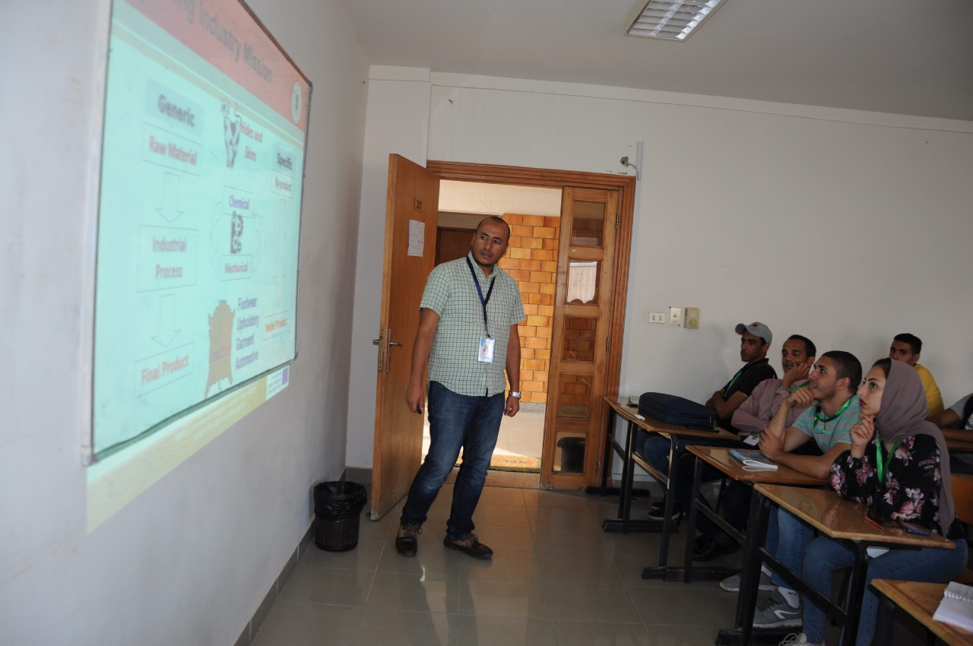

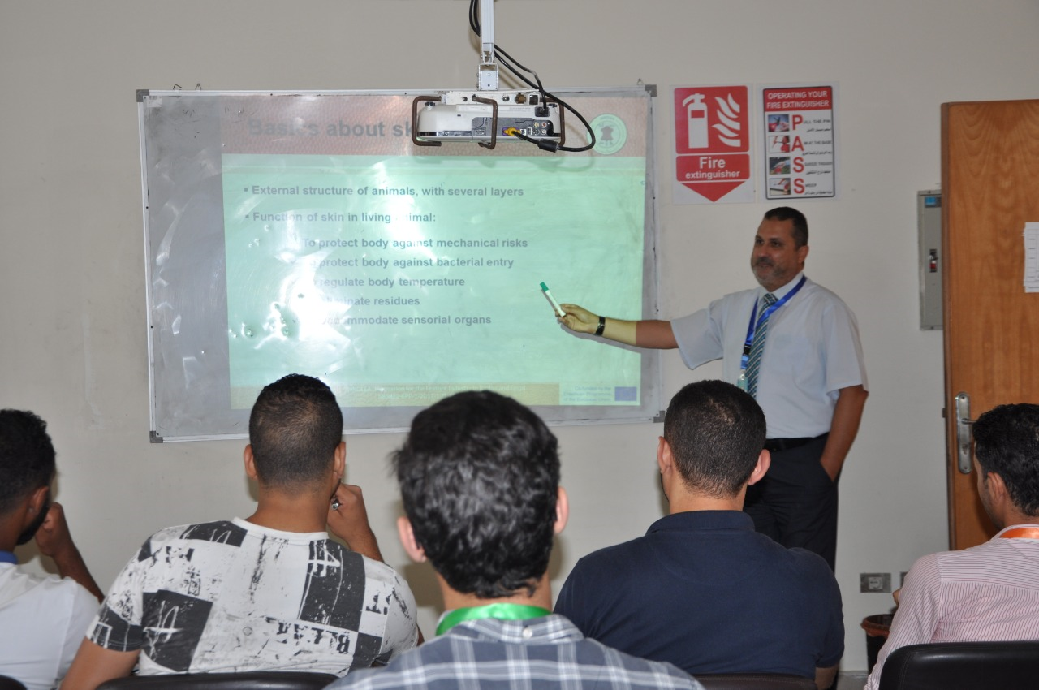
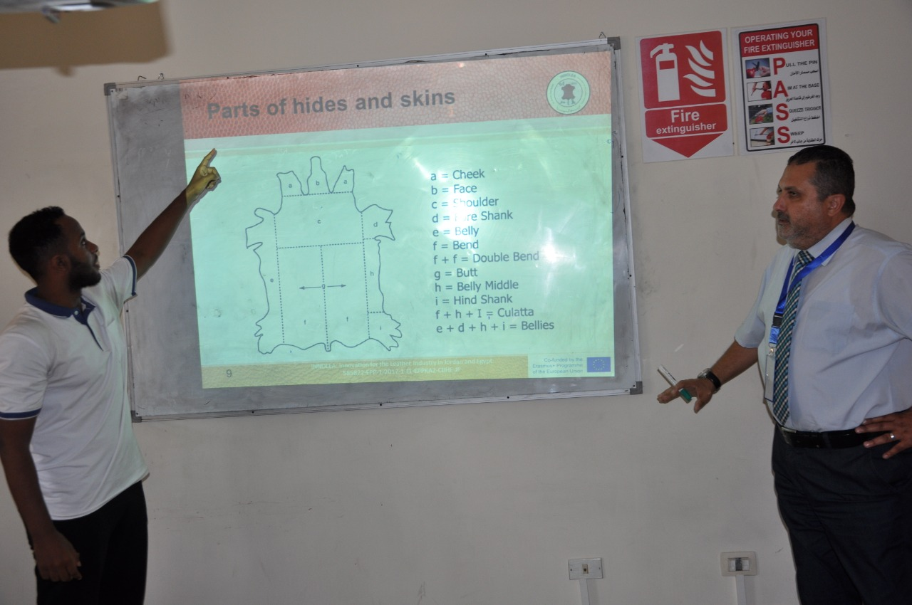

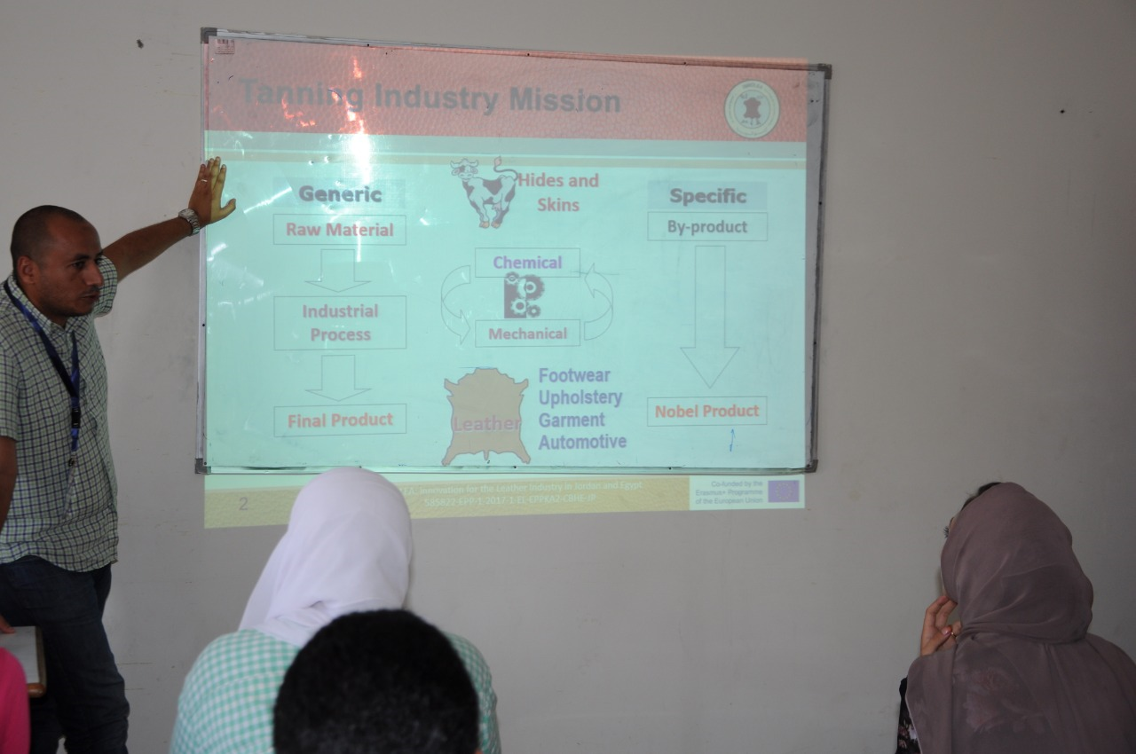

Tests that can be performed:

Determination of Thickness
Determining the thickness of leather. This method is applicable to all types of leather of any tannage. The measurement is valid for both the whole leather and a test sample.

Determination of Apparent density and mass per unit area
Determining the apparent density and mas per unit area of leather. It is applicable to all leathers.

Determination of tensile strength and percentage extension
Determining the tensile strength, elongation at a specified load and elongation at break of leather.

Determination of tear load-single edge tear
Determining the tear strength of leather using a single edge tear. Sometimes is described as a trouser tear. It is applicable to all types of leather.

Determination of tear load- Double edge tear
Determining the tear strength of leather using a double-edged tear. Sometimes is described as a Baumann tear. It is applicable to all types of leather

Measurements of stitch tear resistance
Determining the stitch tear resistance of leather. It can be used on all leathers but it is particularly suitable for leathers over 1.2 mm in thickness.

Test for adhesion of finish
Measuring the adhesion of the finish to leather or the adhesion between two adjacent layers of finish. The method is valid for all finished leathers with a smooth surface that can be bonded to an adherent plate without the adhesive penetrating into the finish. Preliminary experiments might be necessary to determine whether these conditions are met.
This test method is valid for finished leathers with a finish-coat thickness of at least 15 µm.

Determination of flex resistance- Flex meter method
Determining the wet or dry flex resistance of leather and finishes applied to leather. It is applicable to all types of flexible leather below 3.0 mm in thickness.

Test Methods for upper and lining- Flex resistance
Determining the flex resistance of uppers and lining irrespective of the material in order to assess the suitability for the end use.

Footwear- Test methods for uppers and lining—Water vapor permeability and absorption
Specifying two test methods for assessing, respectively, the water vapor absorption of uppers or complete upper assembly irrespective of the material, in order to assess the suitability for the end use.

Determination of water absorption by capillary action (wicking)
Determining the rate of absorption of water by capillary action or wicking in leathers. Applicable to all types of leather.

Determination of water vapor absorption
Determining the water vapor absorption of leather.
The method is applicable for all leathers but is particularly relevant for leathers intended for footwear uppers and linings.

Determination of water vapor permeability
Determining of water vapor permeability of leather and provides alternative methods of sample preparation.

Technical Support
- Press-cutting for industrial scale samples
- Lab-scale Leather Tanning
- Lab-scale Leather Dyeing

Consultancy Services to tanneries and leather processing companies

Contact
Industry Service Complex, Arab Academy for Science and Technology and Maritime Transport
Dr. Ahmed Shoair, +2012234007559, Eng. Yassin Shaalan, +201006009989.

