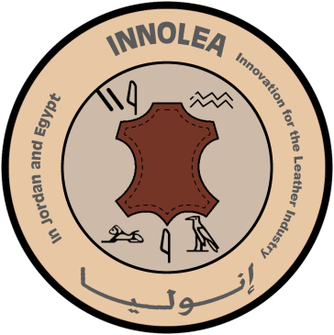

Innovation for the Leather Industry in Jordan and Egypt
INNOLEA
CBHE 585822-EPP-1-2017-1-EL-EPPKA2-CBHE-JP.

BAU Leather Testing Lab
Center Services
List of services provided by the Center
Leather Testing Lab at Al-Balqa Applied University

Author: AL Balqa Applied University (BAU) Team

October 2020

Revision History

Version | Date | Author | Description | Action | Pages
1.0 | 14/10/2020 | BAU team | Creation of the document | C | 7
1.1. | 30/03/2020 | BAU team | Updated of the document | U | 7

(*) Action: C = Creation, I = Insert, U = Update, R = Replace, D = Delete

Disclaimer

This project has been funded by the Erasmus+ Programme of the European Union.
The information and views set out in this publication are those of the author(s) and do not necessarily reflect the official opinion of the European Union. Neither the European Union institutions and bodies nor any person acting on their behalf may be held responsible for the use which may be made of the information contained therein.
Reproduction is authorized provided the source is acknowledged.
All rights reserved
Copyright ©INNOLEA Consortium, 2017-2021

Table of Contents
1. List of services provided by the Center of Excellence in Leather Industry at Al-Balqa Applied University (BAU) 4
1.1 Testing services 5
1.2 Tanning services 5
1.3 Training services 5
1.4 Organizing training workshops and seminars 6
1.5 Consultancy services 6
1.6 Quality testing of leather products 6
1.7 Certification of leather products 6

List of services provided by the Center of Excellence in Leather Industry at Al-Balqa Applied University (BAU)
Work is underway to develop a Leather Center and encourage investment to achieve comprehensive and sustainable growth in Jordan.
The Leather Testing Laboratory was established at Al-Balqa Applied University (BAU) - Faculty of Engineering and Technology, with funding from the Erasmus+ Program after a team from the university undergo training in order to establish this laboratory. The center’s work plan includes organizing events, seminars and workshops at the beginning, to introduce the Center’s activities that will include professional training courses for students, as well as consulting activities for the local sector interested in leather manufacturing and providing a quality certificate for leather products after testing the quality of these products in the laboratory, and the purpose of this is to improve the quality of leather products in Jordan and increase the demand for the leather industry.
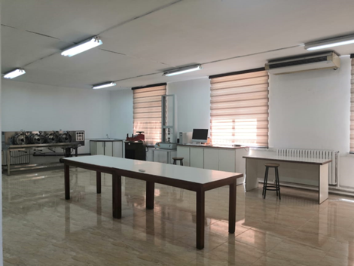
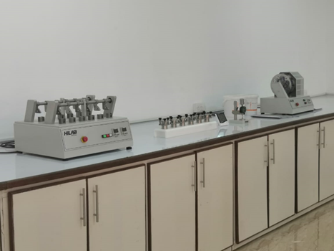

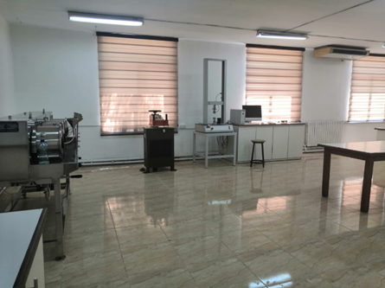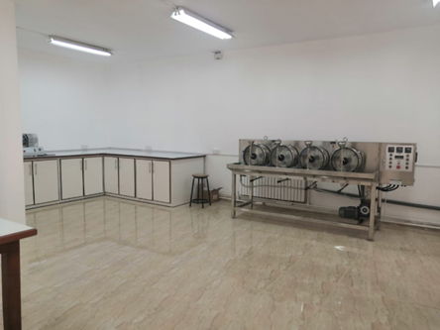
Figure 1. Photos of The Leather Testing Laboratory at BAU

1.1 Testing services
The Center is ready to offer different physical, chemical and mechanical tests, which include:
1. Determination of Thickness and Apperance
2. Determination of tensile strength and percentage extension, Determination of tear load-single edge tear, Determination of tear load- Double edge tear and Measurements of stitch tear resistance.
3. Determination of flex resistance- Flex meter method.
4. Determination of Water vapor permeability.
5. Determination of Water absorption.
6. Determination of Colour fastness.
7. Leather - Determination of PH.

1.2 Tanning services

Testing lab drums (equipment with 4 small scale (interior volume of 5L), with independent temperature and rotation velocity control. Lab test drum for tanning leather and for multi process such as liming, deliming, tanning and retanning to test before real tanning, mainly used for small batch and multi-variety test of various leathers, so as to obtain the best technology.

1.3 Training services

- Comprehensive training, covering all aspects of leather explaining the main stages of leather processing, from curing to tanning through studying different skin types and knowing available techniques in tanning.
- Intensive programs for both experienced professionals and beginners alike.
- Understand different physical, chemical and mechanical test methods performed in accredited laboratories to inspect the quality of leather according to ISO methods.
- Learn how to start and develop the leather industry and increase local production.

1.4 Organizing training workshops and seminars
The Center focuses on holding workshops and seminars to define our goals and the services of the center for stakeholders such as leather product workshop owners, their work teams, graduates interested in working in the leather field, researchers, and students to encourage them to take an interest in the leather industry.

1.5 Consultancy services
The center provides advice to stakeholders who request it.

1.6 Quality testing of leather products
The Center will provide the latest versions of the general standard specifications for specifications and quality that are compatible with international standards, and which can be viewed for those who request them.

1.7 Certification of leather products
The Center will examine and certify the leather products after examining them in accordance with the requirements of the leather standards and award a certificate to those who request them.

