INNOLEA

D4.1 Dissemination and Exploitation Plan

Produced by:
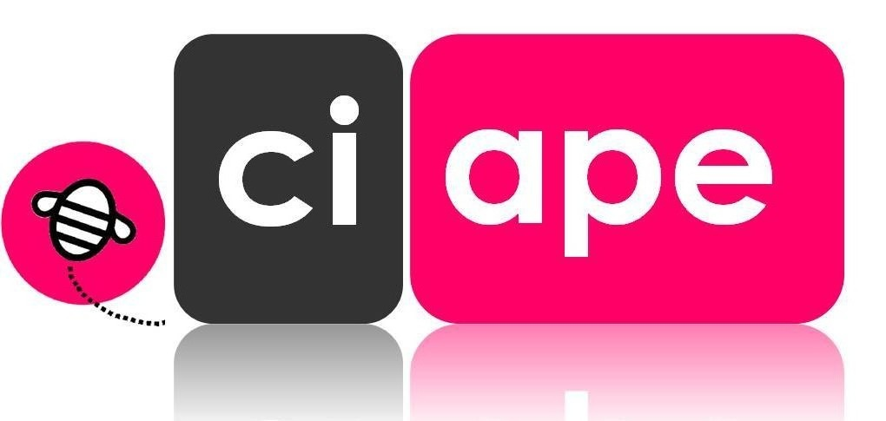

Index
Index 2
1. Project summary 3
2. Objectives of the Dissemination and Exploitation Plan 4
2.1. Introduction 4
2.2. Partners involved 5
3. Target groups 6
3.1. Target groups 6
3.2. Data base for contacts and mailing 6
4. Dissemination and exploitation plan 8
4.1. List of activities 8
5. Communication tools 10
5.1. Mailing list 10
5.2. Project meetings 14
5.3. Dropbox 14
5.4. Newsletters 14
5.5. Whatsapp 14
5.6. Social media 14
5.7. Project website 14
5.8. Events 15
6. Products for exploitation and sustainability 16
6.1. Collaboration platform 16
6.2. Sustainable business model for Leather centres 16
6.3. Recommendations “How leather centres are useful for the economic development of the region” 16

Project summary
INNOLEA project aims to fill an apparent gap in the area of specialized services for the leather sector with the establishment of four leather centres in local Universities, two in Jordan and two in Egypt, utilizing the experience and expertise of EU partners in the area of services for the leather sector.
Through the creation of these centres and the further tasks that will be implemented in this project, the leather sectors in Jordan and Egypt will be offered access to business development services, such as quality testing, product certification, training, fashion trends, production organization, BtoB and funding opportunities, and subsequently the Jordanian and Egyptian leathers sector will have a valuable ally for its further development.
The project also aims to create and maintain a link between Universities and businesses of the leather sector that will foster innovation and the manufacturing of high value quality products, as well as further cooperation between EU and Jordan and Egypt Universities and leather businesses.
The project also aims to help encourage the Egyptian and Jordanian governments to favour the establishment of leather centres within universities and to promote research and projects between EU and Egypt and Jordan universities in the leather sector, by creating a research innovation and training network, which will continue to operate and after the end of the current project.

Objectives of the Dissemination and Exploitation Plan

Introduction
Communication and dissemination management concerns the planning, organising, leading and controlling of the communication flow, with the objective of ensuring an effective leadership, a good relation among partners and with project stakeholders and adequate information flow.
Communication and dissemination is different from exploitation; the first consists of targeted actions to inform and promote the project, the latter provides means to present project products and results to stakeholders, with the aim of promoting their use by the audience.
Dissemination and Exploitation will be an on-going activity and will start at the very beginning of the project and will last even after its end.
The dissemination and exploitation will be lead by Ciape but created and agreed by all project partners; the partnership as a whole will carry out specific promotion, communication and dissemination activities based on the application form, the agreed strategy and the resources and means owned.
Communication and dissemination will be implemented at two levels:
- Internal communication and dissemination, that means communication and dissemination among the partnership and to the staff of the involved organisations,
- External communication and dissemination, that means communication and dissemination outside the partnership which will be implemented at:
  - Target countries: Egypt and Jordan
  - European level;
  - National and regional/local level.

Internal communication and dissemination is extremely important to assure:
- Smooth communication among the organizations involved;
- Strong team spirit;
- Good cooperation among the partners;
- Interest and commitment of all partners to the project;
- Awareness among the internal staff of the existence of INNOLEA project.
External communication and dissemination is fundamental to assure:
- The involvement of the target groups in INNOLEA activities and events;
- The promotion of projects objectives, activities and results toward the target group;
- The visibility of the INNOLEA project to the broad audience;
- The awareness on the concerned domains among the broad audience.
The present document presents a detailed Dissemination and Exploitation Plan, which is the main strategic and operational internal document and defines:
- Project target groups (primary and secondary)
- Communication objectives and strategy
- Communication channels/tools to be used
- Plan of action
- Partners roles and contribution
- Timing for action
- Products to be exploited

Partners involved
All the project partners share responsibility for dissemination and exploitation.
In the description of WP4, roles are clearly defined and tasks clearly and appropriately allocated among partners.
Ciape will have a coordination role and will assure that activities will be implemented on time and by all partners; besides that, it will be responsible for calling corrective actions in case problems arise (this task will be implemented in collaboration with the lead applicant).

Target groups

Target groups
INNOLEA project focus aims at The project aims at the creation of four leather centers (two in Jordan and two in Egypt) within HEIs project partners. These centers will play the role of focal points for the leather sector and relevant stakeholders. Therefore, they can be considered the primary target group.
Besides that, other relevant stakeholders at local/regional and national level are (in target countries as well as in European ones): universities, leather and related companies, BIOs, policy-makers, training centres, investment promotion agencies, corporate executives and investors, International Finance Institutions providing funds for development, researchers and academics and representatives of civil society.
Internal communication and dissemination will be mainly targeted to the partners and to the staff working within the involved organisation.
Students of the academic partners will be also reached by communication and promotion activities.
.

Data base for contacts and mailing
An extremely important activity for dissemination and exploitation purposes will be the D4.2 Data base for contacts & Mailing, which will consist in a database of contacts interested in project results and activities. Contacts will be recipients of the newsletters and will be informed of each project step. This list will be extremely important in the last year of the project when the leather centers will be set up and it will constitute the base of the exploitation strategy.
The collection of contacts will be implemented using the excel table provided below.
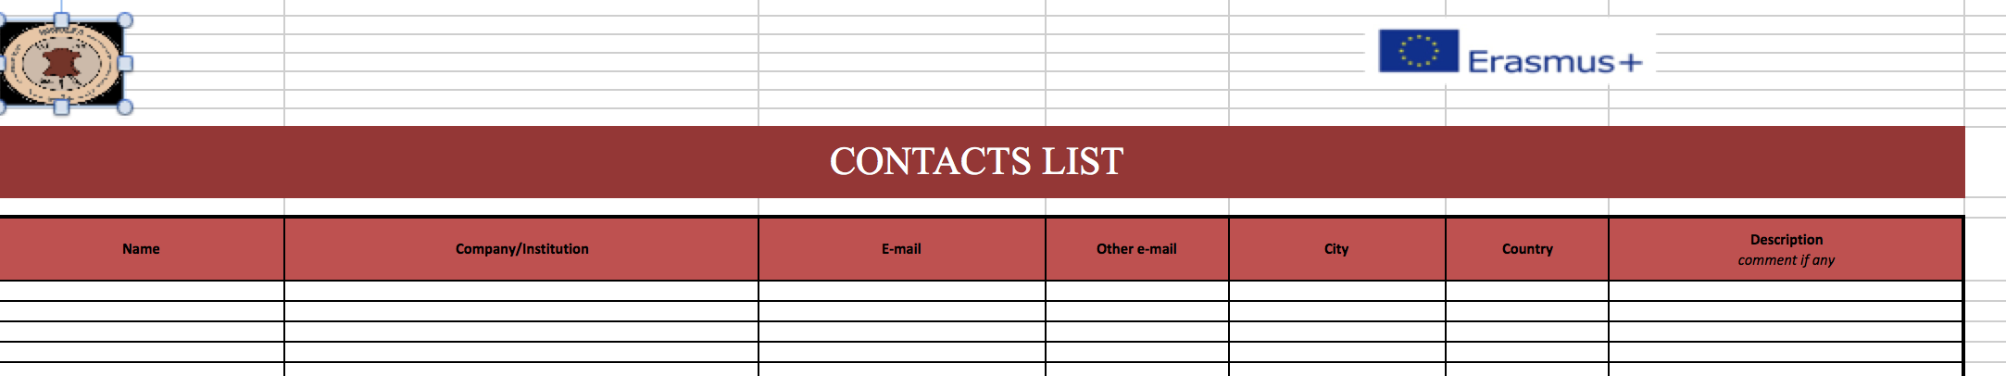
Ciape is responsible of checking partners’ lists of contacts and eliminate the e-mails indicated more than one times. A final database will be then approved.

Dissemination and exploitation plan

List of activities
Activity | Month | Targets | Responsibility
D4.1 Dissemination and Exploitation Plan (1) | May 2018 | Project partners | CIAPE
D4.2 Data base for contacts & Mailing (1) | May 2018 | Project partners | CIAPE
D4.3 Project website and online collaterals (3+6) | From May 2018 to the end of the projects  Newsletters: June 2018- November 2018- June 2019- November 2019 – June 2020- November 2020 | Relevant stakeholders | Amman Chamber of Industry, CIAPE, South Valley University, Jordan University of Science & Technology
D4.4 Dissemination material (3) | May 2018 | Relevant stakeholders | South Valley University
D4.5 Sustainable business model for Leather centres (1) | April 2020 | Relevant stakeholders | CIAPE, Al-Balqa Applied University, Arab Academy for Science Technology and Maritime Transport
D4.6 Background papers (2) | May 2020 | Relevant stakeholders | Kaunas University, Arab Academy for Science Technology and Maritime Transport, Al-Balqa Applied University and Amman Chamber of Industry
D4.7 Roundtables (2) | June 2020 | Relevant stakeholders | Amman Chamber of Industry and Arab Academy for Science Technology.
D4.8 Recommendations How leather centres are useful for the economic development of the region” (1) | July 2020 | Relevant stakeholders | CIAPE, Kaunas University, Amman Chamber of Industry and Al-Balqa Applied University
D4.9 Follow-up report (1) | August 2020 | Relevant stakeholders | All target countries universities
D4.10 Final conference (1) | October 2020 | Relevant stakeholders | Arab Academy for Science Technology

Communication tools

Mailing list
Internal communication among the partners will be guaranteed by e-mails. Ad hoc telephone and Skype calls can be organised by the applicant (or by each WP leader) to solve specific issues. The internal mailing list includes the following contacts:
NAME | SURNAME | ORGANISATION | Tel | Skype | E-MAIL
Andreas | Andreopoulos | NATIONAL TECHNICAL UNIVERSITY OF ATHENS |  |  | andrea@central.ntua,gr
Mahmoud Sayed | Abd El Sadek | South Valley University | +201001741726 | msz_2010 | mahmoud.abdelsadek@sci.svu.edu.eg  elsadek99@gmail.com
Youssuf Ahmed | Gherbawy | South Valley University |  |  | youssufgherbawy@yahoo.com
Emad | Ali | South Valley University |  |  | ealy21@yahoo.com
Sahar | El Barky | Arab Academy for Science Technology & Maritime Transport |  |  | selbarky@hotmail.com, selbarky@aast.edu
Gamal | Haikal | Arab Academy for Science Technology & Maritime Transport |  |  | Gamal.haikal@gmail.com, g_haikal@aast.edu
Sandra | Haddad | Arab Academy for Science Technology & Maritime Transport |  |  | sandra_hdd@yahoo.com
Sara | Elgazzar | Arab Academy for Science Technology & Maritime Transport |  |  | sara.elgazzar02@gmail.com
Irene | De Laurentiis | CENTRO ITALIANO PER L'APPRENDIMENTO PERMANENTE |  | idelaurentiis | opportunities@ciape.it
Eleonora | Perotti | CENTRO ITALIANO PER L'APPRENDIMENTO PERMANENTE |  | Perotti_ciape | ciape@ciape.it
Desiree | Scalia | CENTRO ITALIANO PER L'APPRENDIMENTO PERMANENTE | +393479044127 | Desyscalia2710 | training@ciape.it
Dimosthenis | Papakonstantinou | CREATIVE THINKING DEVELOPMENT | +306944506065 | dimosthenis_p | dpapakon7@yahoo.gr
Lina | Tsakalou | CREATIVE THINKING DEVELOPMENT | +306978902458 | lina.tsakalou | ltsakalou@gmail.com
Alcino | Martinho | Centro Tecnológico das Indústrias do Couro | +351961384100 |  | alcinomartinho@ctic.pt
Joaquim | Gaião | Centro Tecnológico das Indústrias do Couro | +351961384090 |  | joaquimgaiao@ctic.pt
Dana Corina | Deselnicu | UNIVERSITATEA POLITEHNICA DIN BUCURESTI | +40721295347 | danadanac | d_deselnicu@yahoo.com
Gheorghe | Militaru | UNIVERSITATEA POLITEHNICA DIN BUCURESTI | +40744333729 |  | ghmilitaru.militaru@gmail.com
Anca Alexandra | PURCAREA | UNIVERSITATEA POLITEHNICA DIN BUCURESTI | +40744523369 |  | apurcarea@gmail.com
Virginija | Jankauskaite | KAUNO TECHNOLOGIJOS UNIVERSITETAS |  |  | virginija.jankauskaite@ktu.lt
Virgilijus | Valeika | KAUNO TECHNOLOGIJOS UNIVERSITETAS |  |  | virgilijus.valeika@ktu.lt
Viorica | Deselnicu | INSTITUTUL NATIONAL DE CERCETARE-DEZVOLTARE PENTRU TEXTILE SI |  |  | vdeselnicu@gmail.com
Luminita | Albu | INSTITUTUL NATIONAL DE CERCETARE-DEZVOLTARE PENTRU TEXTILE SI |  |  | luminita.albu@gmail.com
Fahmi | Abu Al Rub | Jordan University of Science & Technology | 00962796275161 | Fahmi.rub@outlook.com | abualrub@just.edu.jo
Ruba | Hasan | Jordan University of Science & Technology | 00962797280012 | RuBa HaSan 000 | haruba2014@gmail.com
Fadel | Al-Labadi | Amman Chamber of Industry | 00962777480332 |  | smes_manager@aci.org.jo,  Fadel.Labadi@aci.org.jo
Tariq | Al-Azab | Al-Balqa Applied University | 00962799097077 |  | tazab@bau.edu.jo
Ehab | Al-Ghabeish | Al-Balqa Applied University | 00962795222945 |  | balappuniv@yahoo.com

Project meetings
Internal communication among the partners will be fostered through face-to-face meeting. 7 project meetings have been set.

Dropbox
Dropbox has been chosen as a way of managing INNOLEA project and therefore of facilitating internal communication and the storage of files, pictures and documents.

Newsletters
Periodic newsletters (n. 6) will be elaborated during the project, based on the above-presented calendar. The newsletters will contain information and news linked to the project and aim at communicating project activities to the relevant stakeholders. A template for the newsletter will by elaborated by South Valley University that will be responsible for asking partners contents for the newsletters and selecting them. For privacy reasons, newsletters will be sent by each partner to its own database.

Whatsapp
Communication will be also implemented by Whatsapp in target countries (for those contacts who do not have an e-mail and/or prefer to be contacted through Whatsapp). Messages will contain information and news linked to the project and aim at communicating project activities to the relevant stakeholders

Social media
INNOLEA is present in the following social media:
- Facebook;
- Twitter.
Project social media will be created by South Valley University and which will be constantly updated. Project social media will contain news on project activities, project progresses, project products. The contents will be monitored by CIAPE and South Valley University,; partners will contribute with contents. The use of social media will ensure a multiplier effect and therefore will assure to reach a broad target.

Project website
A project website http://innolea.just.edu.jo/ is set up and constitutes the main way of external dissemination and exploitation, being a meeting place for interactions between partners and other stakeholders interested in the project.

Events
Two roundtables with the titles “Leather centres development and Investment promotion for inclusive and sustainable growth in Jordan” and “Leather centres development and Investment promotion for inclusive and sustainable growth in Egypt” will be organised by Amman Chamber of Industry and Arab Academy for Science Technology.
The final conference will be organised by Arab Academy for Science Technology during the last month of the project. The conference will allow the meeting between project members and stakeholders and will aim at promoting the transferability of the project. Recommendations “How leather centres are useful for the economic development of the region” will be printed and disseminated during the event. 100 people will be expected.

Products for exploitation and sustainability
The main products which will guarantee the sustainability of the project are: the collaboration platform produced under WP2, the Sustainable business model for the leather centres and the Recommendations “How leather centres are useful for the economic development of the region” .

Collaboration platform
The collaboration website platform will be a virtual space aiming at favouring collaboration between:
- the new- established leather centers,
- leather centers and companies both European and of the target countries,
- leather centers and other relevant stakeholders, such as policy-makers, Bios and research centers
- leather centers and initiative groups who would like to create other leather centers/ universities interested in setting up leather centers.
This platform will be a collaborative workspace, ground of new projects and joint activities.

Sustainable business model for Leather centres
The sustainable business model for the leather centres will set the basis for the sustainability of the new-born centers after the lifetime of the project as well as for the creation of new ones in the region. It will be disseminated to relevant stakeholders.

Recommendations “How leather centres are useful for the economic development of the region”
Recommendations “How leather centres are useful for the economic development of the region” will be drafted in order to encourage the uptake of relevant measures to favour the spread of leather centers as well as the development of the leather sector in Egypt and Jordan.

